# 

# THE FRAG

# 2D Recon Battalion Association Newsletter Spring 2025

Greetings Marines, Corpsmen, and Recon Families,

I hope this finds all of you doing well. It’s hard to believe a new year is well under way, and within a few months we will be getting together at good old Camp Lejeune.

Our bond with the Battalion continues to grow. Though it is a sad task, we now support the cost of placing plaques on the memorial at the headquarters when a Marine or Corpsman is killed, whether in the line of duty or an accident. We lost a retired Marine, LtCol. Patrick E. Fuller to MDS at age 70 and an active-duty Marine to a traffic accident. (see In Memoriam).

LtCol. Doykos will relinquish command to LtCol. Epps around reunion time. LtCol. Epps is a former 2d Recon executive officer, so it’s like coming home for him. Both plan to be at the reunion dinner.

I am very excited to announce that thanks to the hard work of our membership chair, Jerry Newland, and our treasurer, Dave Leathers, the new website will soon be operational and in use for reunion registration. Our old website was very expensive and not at all user friendly. The new site will be saving us a lot of money and headache. Bravo Zulu, Jerry and Dave!

Mike Graham is running another memorial paver sale. See the website or contact Grambo at 423-707-5757.

Wayne Dillon

President

sp

Also in this issue is the book review of *Inside Force Recon* by Michael Lanning and Ray Stubbe, and for your entertainment, a short story titled *Don’t Mess with Our RIPsters!*

Semper Fi,

Wayne Dillon

President, 2d Reconnaissance Battalion Association

M

**Contents**

1. **Editor’s Letter**
2. **In Memoriam**
3. **Jarheads Getting Together**
4. **Book Review: *Tough, Rugged Bastards***
5. **Reunion 2025**
6. **Supporting our Community**
7. **Membership**

**In Memoriam**

**LtCol. Patrick Fuller USA (Ret.)**

LtCol. Patrick Eli Fuller, age 70, of Dodgeville, Wisconsin, passed away on Thursday, January 30, 2025 after a courageous battle with MDS. Patrick was born on February 24, 1954 to Sam and Irene Fuller in Rossford, Ohio.  He was the eldest of seven children.  Pat chose to attend St. Francis de Sales High School, for which he paid his own tuition and graduated in 1972.  At the age of 18, Pat enlisted in the US Marine Corps from 1973 to 1986. As an infantry Marine, he served as team leader, squad leader, infantry instructor, and platoon sergeant.

I first encountered (then) Captain Fuller at Ft. Benning in 1986. He came up and started talking to me about my unit, 2d Battalion, Fourth Marines. I’m wondering, who is this Army officer? Some intel guy? He had served with 2d Recon and left the Marine Corps during one of the draw downs which were only offering warfighters support jobs to stay on. The second time I encountered him was when I was Bravo 1’s platoon sergeant in 1993. We received a tasking to work with the 18th Airborne Corps Long Range Surveillance Company at Fort Bragg. Guess who was the company commander? Yes, Captain Fuller. It was a great training event. He was a great leader of Marines and Soldiers as an enlisted man and an officer.

Semper Fi, Sir.

**In Memoriam**

**SSgt. Josheph Paschall, Jr.**

We lost SSgt. Joseph “Joe Joe” Paschall, Jr. in December of last year in a vehicle accident. As a military child born at Camp Pendleton on February 29th, 1996, he lived at multiple duty stations in the United States and overseas. After high school he enrolled at Auburn University and in 2016 joined 3d Force Reconnaissance Company (Reserve) at Mobile, Alabama and successfully completed the Basic Reconnaissance Course in 2018. Soon thereafter, he made the decision to transition from the reserve component to active duty and reported to 2d Reconnaissance Battalion at Camp Lejeune. After checking in to 2d Recon, he was placed in a team leader billet. Joe cherished this position because it not only highlighted his leadership and development skills but also his ability to connect with his Marines and cultivate his interpersonal relationships with them.

Joe deployed as a Team Leader with the 26th MEU (SOC) on the USS Bataan and was promoted to Staff Sergeant on January 1, 2024. Though SSgt. Paschall held a lengthy list of accomplishments, he was most proud of becoming a Joint Terminal Attack Controller (JTAC). He worked tirelessly on his craft and eventually became a JTAC Instructor (JTAC-I) where he shared his vast knowledge with Recondos of every rank, optimizing the operational capability of his organization. SSgt. Paschall’s service was recognized with numerous honors, including two Navy-Marine Corps Commendations Medals, Navy-Marine Corps Achievement Medal, Good Conduct Medal, Naval Parachutists Award, Combatant Dive Insignia, numerous campaign awards, among other commendations.

**Jarheads Getting Together**

**4**

**3**

**2**

**1**

**(see next page)**

**Jarheads Getting Together (cont’d.)**

One of the many benefits of being a Marine, and particularly a member of an association, is the comradery that continues long after active service. This past year, I have benefited immensely from this bond. A few photos:

1. Hog hunting in Florida in February of this year. Left to right: Me, Jim Flannery (Bravo 1) and Jamie Clovis, our host. (Bravo Co. 1/6, 22d MEU).
2. Jim Flannery with a wild boar.
3. Hog hunting in Mississippi in January. Left to right: Me, Mr. Billy (99 years old, Iwo Jima veteran, 28th Marines, 5th Marine Division), and Todd Neal, our host (3d Force Recon).
4. Deer hunting in Missouri in November with Sean Doran of Charlie Company. Deer hunting was terrible due to weather, but the coyote hunting was great!

**Book Review: *Tough, Rugged Bastards***

**By John A. Dailey**

**Task Unit Raider in Iraq, 2004**

I discovered GySgt. John Dailey (Ret.) while listening to the *Combat Story* podcast hosted by Ryan Fugit on Spotify. It was so captivating that I listened to it three times! John started out as an infantry Marine, sniper and served with 1st Force Recon. *Tough, Rugged Bastards* tells the story of the Marine Corps’ entry into the special operations arena.

Prior to the Global War on Terror, the Marine Corps had resisted becoming affiliated with Special Operations Command (USSOCOM), arguing that the Marine Expeditionary Forces’ special operations qualifications were already making that contribution. However, the Secretary of Defense, Donald Rumsfeld declared that the Marines were needed to contribute members to USSOCOM. Though the decree was made, there was no guarantee that the Marines would be accepted by USSOCOM; in fact, there were many betting that the Marine Corps would not fit into this type of operational environment (imagine that).

The eighty-six-man “Detachment One” was formed with a two-year charter to train and deploy as a “proof-of-concept” to assess the viability of a larger Marine Special Operations contribution in support of the Global War on Terror. The Commanding Officer—Colonel Robert J. Coates, a Marine Force Recon legend—was given his pick of personnel. One of the four team leaders he selected was Gunnery Sergeant John A. Dailey. Coates gave Dailey and the others free rein to select their men from a crew of proven Force Recon Marines with the sole stipulation that they be: “Tough, rugged bastards with strong backs and hard feet.” **(cont’d.)**  
  
**(cont’d.)**

These men built a unit from nothing, trained for unknown missions in an unknown location, and deployed amid controversy and skepticism. Once in Iraq, they were dubbed “Task Unit Raider” and quickly won over the naysayers who doubted the Marine’s ability to operate successfully in the fluid and unconventional special operations environment**.** Det-1 served as the bridge between the Raiders of World War II and the Marine Raiders of today.

*Tough, Rugged Bastards* may be found on Amazon or where fine books are sold. For more information go to https://www.jadailey.com

**Reunion 2025**

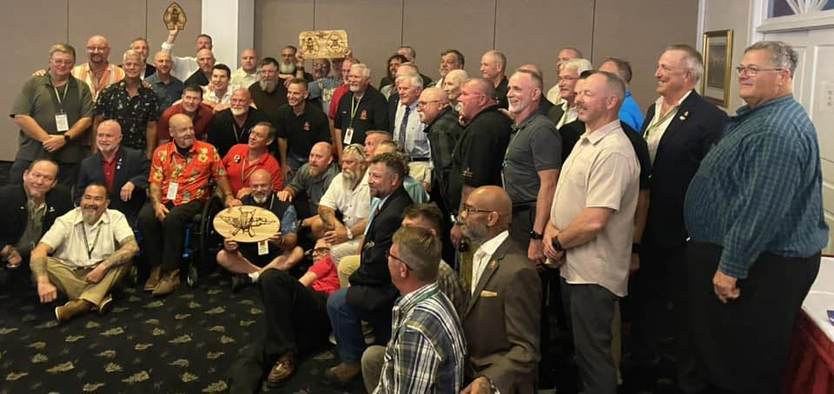

Our reunions just get bigger and better all the time! Plan now for the upcoming reunion, which will be held 26-29 June 2025. We have a group rate of $159.00 per night, which must be reserved before 26 May.

The general plan is to check in to the Hampton Inn Sneads Ferry, NC, on Thursday, 26 June at 1500. Friday will be our day with the battalion to burn their ammo, give awards, eat barbecue, etc. and conduct our membership meeting. Saturday is an open day for visiting the beach, base, etc. until our Association dinner at the in the evening. Sunday is pack up and retrograde.

**Important Note**: There is no “menu pricing” for the reunion, meaning that members cannot pick and choose what events they pay for. All these logistics must be locked on and paid for *months in advance*.

As previously stated, our website is in transition but should be open for registration in plenty of time to register. Check social media for updates. Also on the website will be the link to the Marine Corps Installations East website to register for base access for those who do not have qualifying credentials, such as a retired ID card. More info to come as we get closer to the dates.

To make your reservations, call the Hampton Inn at 910-327-5555. Don’t delay!

**Supporting our Community**

**Scholarships**

Two scholarships are available to Association members and their dependents. The Larry Ashton Memorial Scholarship, administered by the Ashton family, is dedicated to supporting those who are studying to work as health professionals. The Association administers a general scholarship. The deadline for these scholarships is 15 August. For more information, contact Wayne Dillon at [leatherneck75.wd@gmail.com](mailto:leatherneck75.wd@gmail.com).

**Community Support**

The Association has recently been able to provide financial assistance to the family of an active duty who was Marine killed in the line of duty, as well as helping an Association member who encountered hard times. Again, thank you for your generous support. Every dollar given goes to supporting our charitable causes and operating expenses, such as our website. None of the officers take a single penny in salaries or expenses.

# Membership

Jerry Newland is our Membership Chairman. Connect with Jerry with any questions or issues you may have.

Email: gwn8654@gmail.com

Mail: 2nd Recon Association  
Jerry Newland

5231 Hammock Circle

St. Cloud, FL 34771